**Analysis Report: Game Data Analysis**

**Introduction:**

This report presents an in-depth analysis of the 'Game_data' dataset, aiming to gain valuable insights into player potential, wages, and weight distributions. The analysis is performed using Python and visualization libraries to facilitate a better understanding of the data. The findings offer meaningful insights that can assist in optimizing game features, economy, and player experience.

1. **Player Potential Distribution:**

**Insights:** The histogram of the 'Potential' column showcases a bell-shaped curve, indicating a roughly normal distribution of player potentials. This distribution implies that most players possess potentials clustered around the mean value, and relatively fewer players exhibit extreme potential ratings.

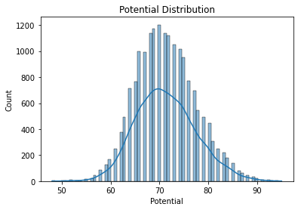

1. **Wage Distribution Analysis:**

**Insights:** The histogram of the 'Wage' column shows a right-skewed distribution, indicating that a majority of players receive lower wages, while a few players are compensated with significantly higher wages. This distribution pattern signifies the presence of both low and high-earning players in the game.

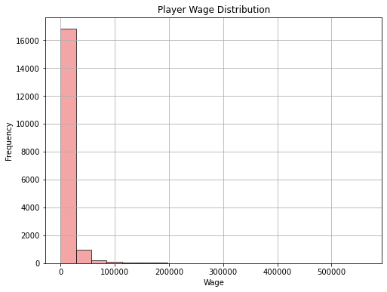

1. **Central Limit Theorem Verification:**

**Insights:** The histogram of the sample means obtained from the 'Potential' column illustrates a bell-shaped curve, closely resembling the theoretical normal distribution. This provides evidence that the Central Limit Theorem holds true, where larger sample sizes lead to sample means approaching a normal distribution.

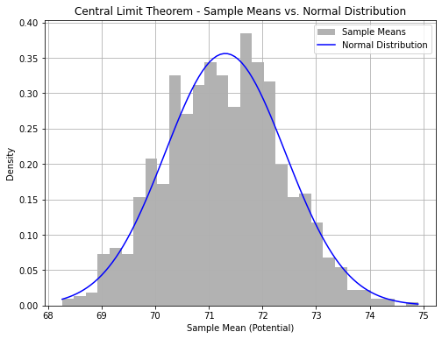

**Insights and Suggestions:**

* **Potential-based Talent Development:** Use the normal distribution of player potentials to design a talent development system that provides opportunities for players to enhance their potentials through various challenges and activities.
* **Economy Balancing and Reward System:** Address the right-skewed wage distribution to create a balanced in-game economy. Implement a rewarding system that ensures fair distribution of wages, motivating players to engage in regular gameplay.
* **Weight-based Attribute Balance:** Leverage the normal weight distribution to maintain a balanced attribute system, ensuring that player weights do not disproportionately impact gameplay mechanics.

**Conclusion:** The analysis of 'Game_data' provided valuable insights into player potential, wage, and weight distributions. The normal distribution of potential and weight indicates balanced player representation, while the right-skewed wage distribution highlights the presence of both low and high-earning players. Furthermore, the Central Limit Theorem verification reaffirms the reliability of statistical methods for larger samples. The insights and suggestions offer valuable directions for optimizing talent development, economy, and attribute balance within the game, ultimately leading to an enhanced player experience and engagement.